Assignment 2
Excel Task Report
Profit Percentage:
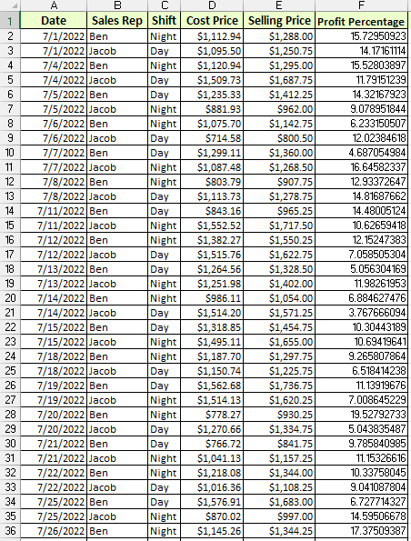
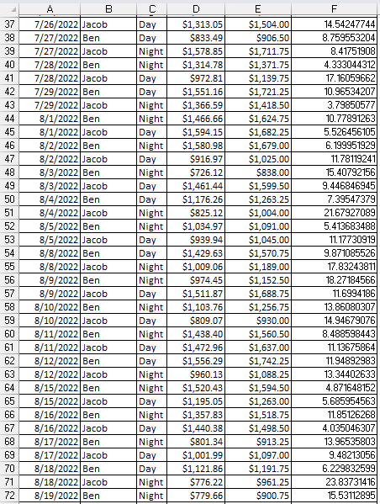

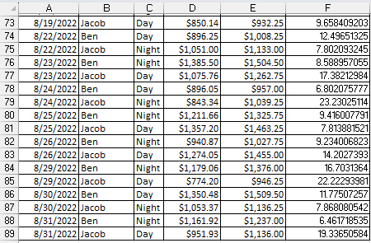
Here, the formula used is:
=((En-Dn)/Dn)*100 , where n={2,3,…,89}
Where, En is the selling price, Dn is the cost price and (En-Dn) is the profit.
The general formula is:
Profit percentage = (Profit/Cost price) * 100
Number of shifts for each Employee:
Ben:
Day shift:
=COUNTIFS (B2:B89, "Ben", C2:C89, "Day")
Night shift:
=COUNTIFS (B2:B89, "Ben", C2:C89, "Night")
Jacob:
Day shift:
=COUNTIFS (B2:B89, "Jacob", C2:C89, "Day")
Night shift:
=COUNTIFS (B2:B89, "Jacob", C2:C89, "Night")

Where, B2:B89 is the criteria range 1, C2:C89 is the criteria range 2 and inside the quotation marks is the criteria for each range respectively.
The general formula is:
=COUNTIFS (criteria_range1, criteria1, [criteria_range2, criteria2], ...)
Here, first criteria range 1 is checked for criteria(condition) if it is true then criteria range 2 is checked for criteria(condition) if it is also true then count number is increased by one. One by one all rows in range are checked. Then the total count number is displayed as result.
Total Income for Jacob:
Day shift:
Here, the formula used is:
=SUMIFS (J2:J89, B2:B89,"Jacob", C2:C89,"Day")
Where, J2:J89 is the range for column of Jacob’s Total Earning of a single item in each row, B2:B89 is the criteria range 1 column and C2:C89 is the criteria range 2 column.
Night shift:
Here, the formula used is:
=SUMIFS (J2:J89, B2:B89,"Jacob", C2:C89,"Night")
Where, J2:J89 is the range for column of Jacob’s Total Earning of a single item in each row, B2:B89 is the criteria range 1 column and C2:C89 is the criteria range 2 column.
Here, is first condition in criteria range 1 column is true, which is to check for Jacob’s name, then the second condition is checked in criteria range 2 column, which is to check for Day or Night, if it is also true then the value in J2:J89 is added to sum. Then the total sum is displayed at the end.
Commission for Sales:
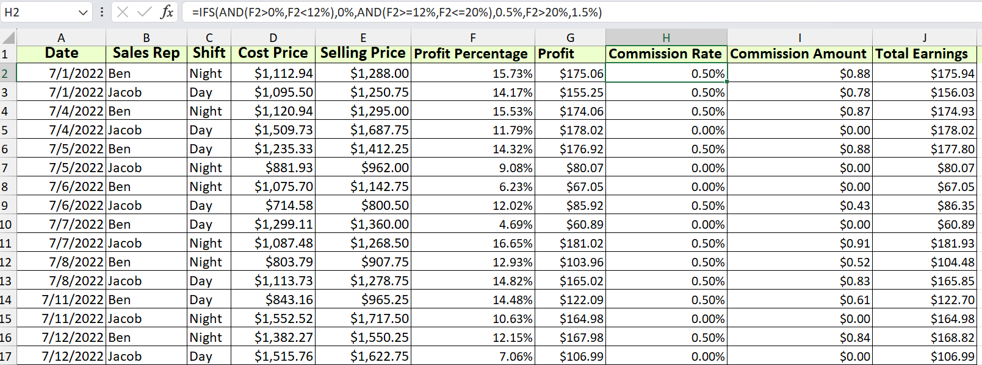
First Commission rate is found by the following conditions:
- If profit percentage is less than 12% then, commission rate is equal to 0%.
- If profit percentage is greater than or equal to 12% less than or equal to 20% then, commission rate is equal to 0.5%
- If profit percentage is greater than 20% then, commission rate is equal to 1.5%.
Here, formula used is:
=IFS(AND(F2>0%,F2<12%),0%,AND(F2>=12%,F2<=20%),0.5%,F2>20%,1.5%)
Here IFS function is used running multiple conditions, AND is used for more than one logical conditions to check for. The arguments in AND are conditions to be checked and if they are true then the argument next to it is the value which will be assigned to the cell fi the conditions are true. In this way, the same process is repeated for other conditions.
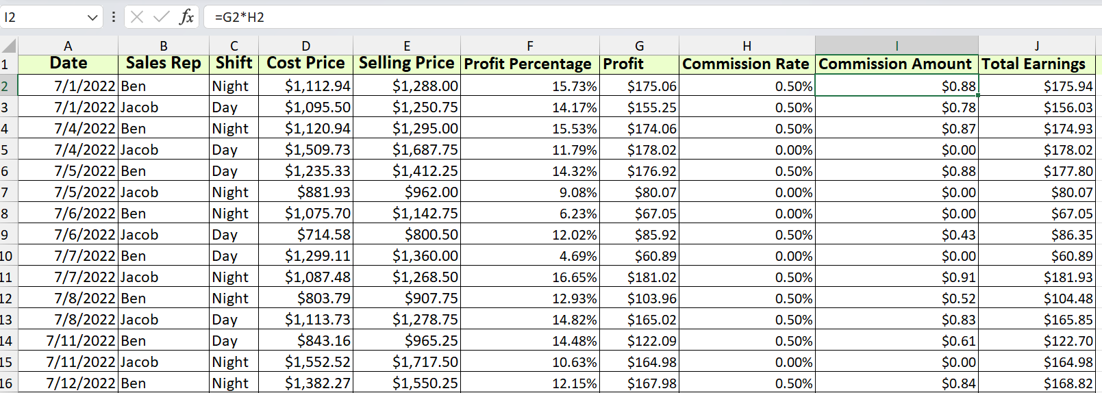
Now Secondly, the commission amount is calculated by simply multiplying the commission rate with profit.
Here, formula used is:
=Gn:Hn , where, n=(2, 3, 4, …, 89)

